# EXERCISE NO 05

**ESTIMATING AND ELIMINATING TREND - AGGREGATION SMOOTHING. AIM:**

To estimate and eliminate trends in time series dataset by aggregation and

smoothing.

# ALGORITHM:

1. Load & Preprocess Data: Read dataset, convert dates, and aggregate monthly.
2. Apply Exponential Smoothing: Use an exponentially weighted moving average.
3. Estimate & Remove Trend: Fit a linear regression model and subtract the trend.
4. Visualize Results: Plot original, smoothed, and detrended series.

# PROCEDURE:

1. Import the necessary libraries:

**import** pandas **as** pd

**import** numpy **as** np

**import** matplotlib.pyplot **as** plt

**from** sklearn.linear_model **import** LinearRegression

1. Load the time series data:

df **=** pd**.**read_csv("C:/Users/Lenovo/Downloads/amazon.csv", encoding**=**'latin1')

1. Pre process the data:

month_map **=** {

'Janeiro': 'January', 'Fevereiro': 'February', 'Março': 'March',

'Abril': 'April', 'Maio': 'May', 'Junho': 'June',

'Julho': 'July', 'Agosto': 'August', 'Setembro': 'September',

'Outubro': 'October', 'Novembro': 'November', 'Dezembro': 'December'

}

df['month'] **=** df['month']**.**map(month_map)

df['date'] **=** pd**.**to_datetime(df['month'] **+** ' ' **+** df['year']**.**astype(str), format**=**'%B %Y', errors**=**'coerce')

df **=** df**.**dropna(subset**=**['date'])

df**.**set_index('date', inplace**=True**)

*# Aggregate data*

df_monthly **=** df**.**resample('M')['number']**.**sum()

df_yearly **=** df**.**resample('Y')['number']**.**sum()

1. Smoothing and Detrending:

df_monthly_smooth **=** df_monthly**.**rolling(window**=**5, center**=True**)**.**mean()

*# Detrending using Linear Regression*

X **=** np**.**arange(len(df_monthly))**.**reshape(**-**1, 1) *# Time index as X*

y **=** df_monthly**.**values

model **=** LinearRegression()

model**.**fit(X, y)

trend **=** model**.**predict(X)

df_detrended **=** df_monthly **-** trend

1. Visualization:

plt**.**figure(figsize**=**(12, 6))

plt**.**plot(df_monthly**.**index, df_monthly, label**=**'Original', alpha**=**0.6)

plt**.**plot(df_monthly**.**index, df_monthly_smooth, label**=**'Smoothed (Moving Avg)', linestyle**=**'dashed')

plt**.**plot(df_monthly**.**index, trend, label**=**'Trend (Linear)', linestyle**=**'dotted', color**=**'red')

plt**.**plot(df_monthly**.**index, df_detrended, label**=**'Detrended', linestyle**=**'dashdot')

plt**.**legend()

plt**.**title('Trend Estimation and Elimination in Time Series')

plt**.**show()

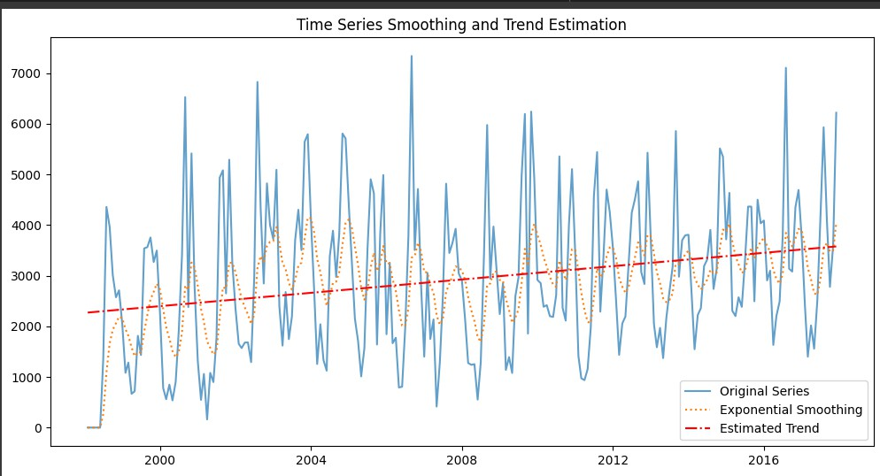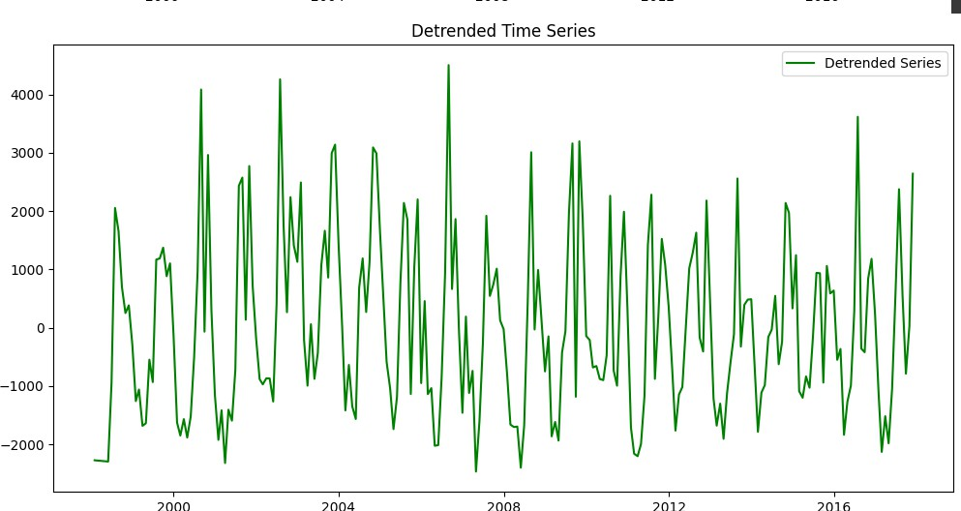**OUTPUT:**